Media Kit

PRECISION ARROW PLACEMENT, LLC
Introduction
Our company resolved to create a precision instrument that would provide the best ranging and aiming solutions all in one device. The objective was to make a quality product and a more efficient system by which a shooter could acquire a target range, automatically receive a target marker for that range and thereby quickly and efficiently take the shot. Thus resulting in a more precise shot for target shooters and a more ethical shot for hunters!
Background
Crux Research (developer of the R.A.Sp1 Bow Hunting Sight) is a small business passionate about development. Crux has been involved in a few developments that we are very proud of. Developments such as the CRAR-32 and GR40 sights for assault rifles and 40mm Grenade Launchers have seen the light with state of the art technology. Ballistic profiles of 32 different ammunition types can be programmed via an infrared port to the GR40 sight.
This technology has brought us to a point where we could develop a sight for the Bow Hunting market. This sight (R.A.S.p1) will not only enable you to make a more precise shot placement but also at the same time compensate for shooting angle and give you the last measured distance to 0.5 yard accuracy through a bright OLED display.
Product
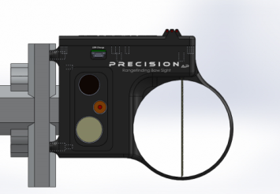
The new RASp1 Laser Rangefinding Bow Sight is a Revolutionary Bow Sighting System. The RAS sight has two components needed to make a precise and ethical shot with a bow and arrow. First it has a laser rangefinder to determine the accurate distance to your target, and second a digital LED system that once calibrated will give the shooter a precise lighted LED for the ranged distance. The calibration and set-up are as easy as sighting in a normal pin sight. The shooter simply determines the ranges that he/she will shoot (Ex. 20-50 yds) and after the RAS sight is calibrated, then there will be an LED light for any distance in that range. PAP Innovations is proud to introduce the New RASp1 Range-Aim-Shoot Laser Rangefinding Bow Sight
RASp1 Bow Sight
Features and Benefits
The features and benefits of the RASp1 bow sight will help target enthusiast and hunters be more precise because it ranges the target and provides the correct Target Marker for that target Automatically!

- Bow Sight and Rangefinder in one unit
- Automatically gives the target marker after ranging
- AFT (Adjusted Flight Technology) has the ability to make adjustments for incline and decline
- Calibrates in minutes and can store up to 10 different arrow sizes
- One touch Scan for continuous ranging of a target
- Minimizes movement and increases efficiency for a more ethical shot placement
- RANGE-AIM-SHOOT
Images
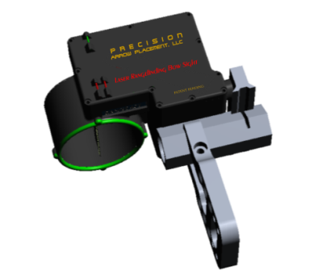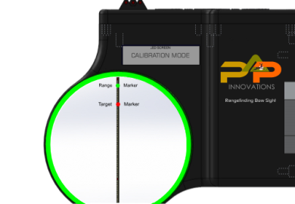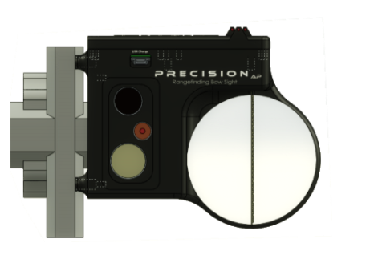
Images are free to use as part of the press release. More available upon request and on our website.
Comments from the 2015 ATA Show
“I was wondering when someone would come out with this sight” ; The RASp1 sight is Transitional for the bow sight industry; “The sight ranges and gives the target marker fast”; “Wow, I really like the Scan feature”; “I really like having the rangefinder and sight in one unit” ; “This bow sight will make an average shooter much better”; “The sight is really lightweight”; “I can’t believe someone finally made this bow sight”; “This bow sight will be a game changer”; “I have to get one of these sights”; “My son wanted me to see this bow sight and I see why”; “This bow sight is the most innovative product I have seen at the 2015 ATA Show”; “I had to come see this bow sight after I heard about it”; “When can I get one of these bow sights?”
For more Information
Contact: David Neck (229)460-3966 or dnecknow@hotmail.com
Jimmy Whatley (229)740-0057 or jwhatley@vwave.net
Website: www.precisionarrowplacement.com
Home office: 2625 Jerry Jones Dr., Valdosta, GA. 31602

